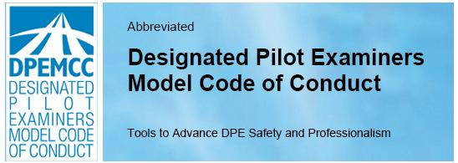
The Designated Pilot Examiners Model Code of Conduct offers recommendations to advance safety and professionalism in the conduct of practical tests. The Code presents a vision of excellence for DPEs. Its principles complement and underscore legal requirements. It is intended to assist in evaluating the core principles that help aviators build a foundation of flight safety, proficiency, and wisdom.
I. General Responsibilities of
Designated Pilot Examiners
Designated Pilot Examiners should:
- make safety a top priority,
b. apply and conform to applicable Airman Certification Standards (ACS) or Practical Test Standards (PTS), as appropriate, and guidance documents, and
c. aspire to professionalism, and represent the FAA Administrator in a professional manner including conduct, language, appearance, and hygiene.

II. Flight Test Safety
Designated Pilot Examiners should:
a. discuss inherent risks or safety challenges of a given flight test with the applicant, address applicant concerns, and
b. consider an applicant’s attention span, workload, and fatigue, and tailor testing scenarios accordingly.

III. DPE Training and Proficiency
Designated Pilot Examiners should:
a. take regular recurrent training to maintain and improve proficiency beyond legal requirements, and
b. participate in flight safety education.

IV. Security
Designated Pilot Examiners should:
- become familiar with the latest security regulations, and
b. avoid special-use airspace except when approved or necessary in an emergency.
V. Environmental Issues
Designated Pilot Examiners should evaluate an applicant’s:
a. efforts to mitigate the environmental impact of pre-flight, in-flight, and post-flight aircraft operations, and
b. efforts to respect and protect environmentally sensitive areas, and adhere to noise-abatement procedures.

VI. Use of Technology
Designated Pilot Examiners should:
a. understand the operation, features, and limitations of aviation technologies in test aircraft sufficiently to (i) act as safety pilot if required, and (ii) effectively evaluate an applicant’s use of the technology, and
- be familiar with the manufacturers’ recommendations for simulating in-flight failures of avionics, tablets and other portable electronic devices.
VII. DPE Professionalism and Safety Culture
Designated Pilot Examiners should:
a. advance a DPE safety culture that values openness, humility, integrity, positive attitudes, and the pursuit of personal improvement,
b. foster professionalism by example, and
c. promote safety education.

Notice
The DPE Model Code of Conduct © Aviators Code Initiative (ACI). All Rights Reserved. Terms of Use: secureav.com/terms.pdf. The abbreviated and full versions of the DPEMCC are available at: secureav.com/DPE-Listings-Page.html. The DPEMCC does not purport to address every safety concern. It is the responsibility of the user to establish appropriate safety practices and comply with regulatory limitations. It is not intended to provide legal advice and must not be relied upon as such.
Acknowledgments: Various subject matter experts have provided input for the UASPC. We gratefully acknowledge their editorial assistance. See secureav.com/ack.pdf.

