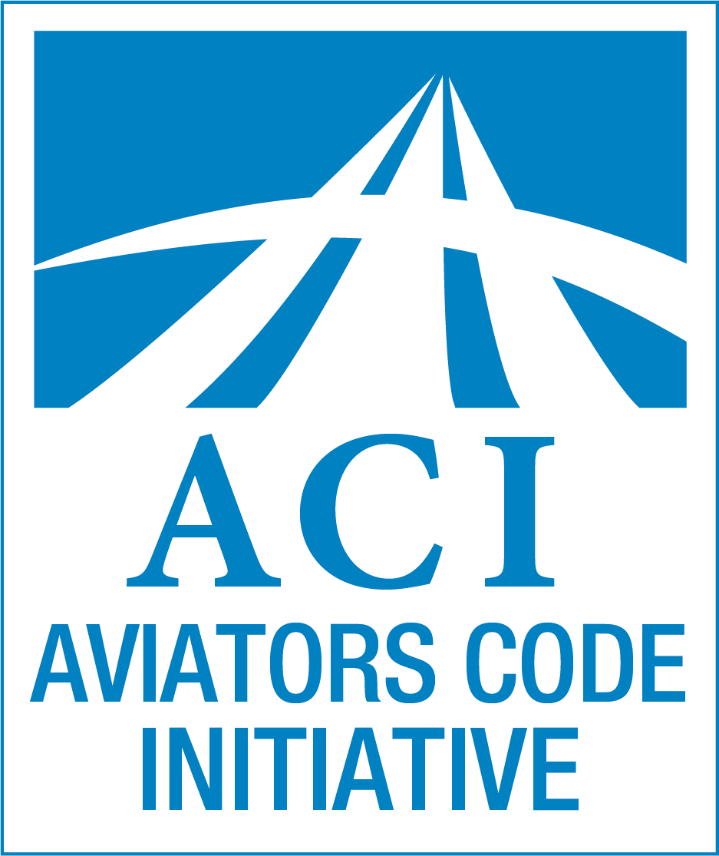

Permanent Editorial Board
of the
Aviators Model Code of Conduct

Michael S. Baum, JD, MBA, ATP
Ric Peri, VP AEA
Stan Rose, ED HSA
Bill Rhodes, Ph.D.
Rusty Sachs, JD, DhE, MCFI
Don Steinman, ATP, CFII
Donna F. Wilt, Ph.D., ATP, CFII

This letter introduces version 3.0 of the Aviators Model Code of Conduct (AMCC). Developed by a team of aviation professionals and drawing upon decades of research and experience, the AMCC recommends operating practices to enhance the quality and safety of your flight operations. The AMCC applies to a range of operating environments, and pilot experience and certifications. Among its many revisions, Version 3.0 provides a general update, enhances treatment of new technologies, and responds to the increasing presence of uncrewed aircraft.
Pilot conduct impacts the entire aviation community, including its safety culture. A code of conduct can help achieve new levels of proficiency. The AMCC is just such a tool, a set of guidelines adaptable to each pilot and organizational need. We encourage you to adopt it, and to commit to the highest ideals of aviation safety.
The AMCC was developed as a volunteer effort and is provided free of charge as a public service. It has been extensively peer reviewed and subject to periodic revision. The AMCC and supporting materials are available at www.secureav.com.
**

[Blank]
Version 3.0

Aviators
Model Code
of Conduct
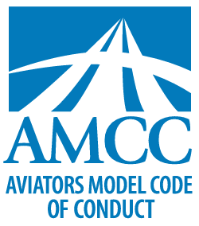
Tools to advance aviation
safety and professionalism

Provided to the aviation community by:
[Insert Sponsoring Entity]

©2003, 2022, Aviators Code Initiative. All Rights Reserved.

Introduction
The Aviators Model Code of Conduct (Code of Conduct) offers recommendations to advance flight safety, airmanship, and professionalism.
The Code of Conduct presents a vision of excellence for aviators. Its principles complement and underscore legal requirements.
The Code of Conduct is a model, not a standard. Users may revise the document—including title, length, and organization—to fit their needs. Provisions and Sample Recommended Practices may be reordered, modified or eliminated to satisfy unique requirements.
The Code of Conduct will be most effective if users have a firm grasp of the fundamentals of flight and a commitment to the pursuit of professionalism.
The Code of Conduct has seven sections, each presenting Principles and Sample Recommended Practices.
The Sections:
I. General Responsibilities of Aviators
II. Passengers and People on the Surface
III. Training and Proficiency
IV. Security
V. Environmental Issues
VI. Use of Technology
VII. Advancement and Promotion of Aviation
The Sample Recommended Practices:
Sample Recommended Practices are suggestions for applying the principles of the Code of Conduct and tailoring them to individuals and organizations. Sample Recommended Practices are not ranked or ordered, although Instrument flight rule (IFR)-specific Sample Recommended Practices generally appear last.
The Commentary:
Commentary on selected provisions of the Code of Conduct is published at www.secureav.com. The Commentary provides discussion, interpretive guidance, and suggested ways to adopt the Code of Conduct. Additional provisions will be added as the Commentary evolves.
Benefits of the Code of Conduct:
The Code of Conduct benefits pilots and the aviation community by:
❑ highlighting practices to support safety and professionalism,
❑ promoting improved pilot training, airmanship, personal responsibility, ethical conduct, and contributions to the aviation community and society at large,
❑ encouraging the development of good judgment and a professional ethic,
❑ advancing self-regulation through the aviation community,
❑ supporting improved communications between pilots, regulators, and others in the aviation community, and
❑ promoting aviation and making flying a more rewarding and enjoyable experience.

Note: References to the United States Federal Aviation Administration (FAA) are used as examples. In all jurisdictions, applicable laws and regulations must be followed.

Aviators Model
Code of Conduct
Principles and
Recommended Practices

I. General Responsibilities of Aviators
Pilots should:
a. make safety the highest priority,
b. pursue excellence in airmanship,
c. develop and exercise sound judgment and sound principles of aeronautical decision-making,
d. recognize and manage risks effectively, and use sound principles of risk management,
e. maintain situational awareness, and adhere to prudent operating practices and personal operating parameters (e.g., personal minimums),
f. aspire to professionalism,
g. act with responsibility and courtesy, and
h. adhere to applicable laws and regulations.
Explanation: These General Responsibilities serve as a preamble to the Code of Conduct’s other principles. They emphasize safety, excellence, risk management, and responsibility.
Sample Recommended Practices:
❑ Approach aviation with seriousness and diligence, recognizing that lives depend on you.
❑ Understand and comply with the privileges and limitations of your certificates, licenses, ratings, and endorsements, and ensure endorsements are correct and current.
❑ Enhance inflight situational awareness by developing a foundation of airmanship, scenario-based instruction, and hazard identification.
❑ Develop, use, periodically review, and refine personal checklists and personal minimums for all phases of flight. Review these materials regularly with an experienced instructor or other trusted mentor.
❑ Recognize and plan for the time and financial resources required to implement proper safety practices.
❑ Be aware of personal susceptibility to, and seek to avoid or manage, distraction, fatigue, stress, and hazardous attitudes.
❑ Make personal wellness and an honest evaluation of your mental and physical fitness a precondition of each flight—for example, by using the I’M SAFE (Illness, Medication, Stress, Alcohol, Fatigue, Emotion) checklist.
❑ Develop prudent personal operating practices that reflect your experience, proficiency, and currency in challenging conditions.
❑ Establish conservative parameters for the use of supplemental oxygen and maintain an awareness of your personal susceptibility to hypoxia. Consider use of a pulse oximeter. Use supplemental oxygen on flights when required by rule or whenever beneficial.
❑ Adhere to applicable rules and operating practices of your airport, flying club, school, FBO, flight center, or aircraft rental provider.
❑ Comply with or exceed applicable requirements for Airworthiness Directives (ADs). Understand the benefits of complying with recommended inspections, Service Bulletins (SBs), and Service Letters (SLs).
❑ Apply principles of safety management.
❑ Implement Crew Resource Management (CRM), Single-Pilot Resource Management (SRM), and procedures standardization including callouts.
❑ Recognize the increased risks associated with flying at low altitude, in inclement weather, at night, in congested areas, over water, and over rugged, mountainous or forested terrain.
❑ See and be seen. Practice techniques for seeing and avoiding other aircraft. Scan for traffic continuously. Enhance your visibility through appropriate use of aircraft lights.
❑ Listen and be heard. Monitor appropriate frequencies to remain aware of other aircraft, and accurately inform other pilots of your position and intentions.
❑ Monitor and report. Identify safety and compliance issues, and communicate them appropriately.
❑ Maintain a sterile cockpit for taxi, takeoff, approach, landing, and other critical phases of flight.
❑ Minimize turns and maneuvers below minimum safe altitudes.
❑ Never allow simulated emergencies to become actual emergencies.
❑ File a flight plan or communicate your intended flight itinerary to ground personnel prior to departure, even when flying locally.
❑ Decline to fly an aircraft that is not airworthy.
❑ Operate rental and other aircraft as if you owned them, and communicate all discrepancies effectively and promptly. Return aircraft in an equal or better state of cleanliness than received.
❑ Identify and adapt to changing flight conditions based on sound principles of decision-making, airmanship, and risk management. Be prepared to alter your flight plan accordingly or abort your flight.
❑ Plan every flight carefully. Calculate weight and balance, and aircraft performance, consider the effect of wind on fuel reserves and range, and consider diversion alternatives.
❑ Remain aware of deteriorating weather and other circumstances that may make continued flight unsafe; either land, divert, or continue under instrument flight rules, as appropriate.
❑ Recognize that new airspace users such as drones or other uncrewed aircraft may pose new risks to safety.
❑ Recognize that drone operations regularly occur at low altitudes and/or within 5 SM of airports.
❑ Consider that many drone operators, especially hobbyists, are not certificated pilots and may not understand or adhere to aviation operations and safety requirements.

II. Passengers and People on the Surface
Pilots should:
a. maintain passenger safety first and then reasonable passenger comfort,
b. manage risk and avoid unnecessary risk to passengers, to people and property on the surface, and to people in other aircraft,
c. brief passengers on planned flight and emergency procedures, and inform them of any significant or unusual risk associated with the flight,
d. seek to prevent unsafe conduct by passengers, and
e. avoid operations that may alarm, disturb, or endanger passengers or people on the surface.
Explanation: Pilots are responsible for the safety and comfort of their passengers. Passengers place their lives in pilots’ hands, and pilots should exercise due care on their behalf. Such care includes, but is not limited to, disclosing unusual risks, and exercising prudent risk management. Pilot responsibility extends to people on the ground, and in other aircraft.
Sample Recommended Practices:
❑ Keep your passengers as safe as possible, as though they were your closest loved ones.
❑ Act professionally towards your passengers.
❑ Require that passengers wear seat belts and shoulder harnesses, and consider providing hearing protection, such as intercom-equipped headsets.
❑ Tactfully disclose risks to each passenger, address their concerns or anxieties regarding flight operations, and accept a prospective passenger’s decision to refrain from participating.
❑ Conduct a thorough passenger safety briefing for each flight (see Additional Resources below), and explain that changing conditions could result in rescheduling or cancellation.
❑ Ascertain the flight experience and concerns of each passenger. Incorporate this knowledge into the safety briefing and flight operation.
❑ Maintain insurance policies for adequate coverage of aircraft, crew and passengers, and understand and comply with all policy terms and limitations.
❑ Instruct passengers to avoid touching or obstructing critical flight controls. Brief passengers to maintain a sterile cockpit during takeoffs, landings, and other workload-intensive times.
❑ Encourage passengers to serve as safety resources, for example by having them identify nearby aircraft or other hazards.
❑ Assess unfamiliar passengers for potential safety and security problems.
❑ Remember that passenger safety begins on the ramp before ever entering the aircraft. Watch passengers and nearby pedestrians closely and keep them clear of hazards (e.g., fuel trucks, propellers, slippery surfaces).
❑ Refuel with passengers on board only when authorized and appropriate, and when the operation can be safely conducted.

III. Training and Proficiency
Pilots should:
a. participate in regular recurrent training to maintain and improve proficiency beyond legal requirements,
b. participate in flight safety education programs,
c. train to avoid complacency, and reinforce the need to remain vigilant,
d. train to recognize and deal effectively with emergencies,
e. prepare for and review each lesson carefully, and
f. maintain an accurate log to satisfy training and currency requirements.
Explanation: Training and proficiency underlie aviation safety. Recurrent training is a primary component of proficiency and should include both air and ground training. Each contributes significantly to flight safety and neither can substitute for the other. To be most effective, training should often exceed legal requirements.
Sample Recommended Practices:
❑ Pursue a rigorous, lifelong course of aviation study.
❑ Consider a training plan that will yield new ratings, certificates, and endorsements.
❑ Develop and follow a training regimen that incorporates the assessment of your progress, ensures your flight instructor or mentor communicates such assessment to you, and provides opportunity for your input.
❑ Invite constructive criticism from your fellow aviators and provide the same when asked.
❑ Learn appropriate use of the aircraft flight manual to determine your aircraft’s limitations, calculate performance, plan flights, properly secure cargo, determine fuel requirements, and calculate weight and balance.
❑ Understand and appreciate your roles and responsibilities as pilot in command, including declaring an emergency without hesitation.
❑ Develop decision-making skills to include hazard identification and risk management. Task- and scenario-based training will help integrate stick-and-rudder, cockpit technology, and aeronautical decision-making skills.
❑ Train for flight in challenging weather conditions and environments such as over water or remote, desert, or mountainous terrain.
❑ Train for survival, and carry adequate survival equipment, apparel, and drinking water.
❑ Understand the unique risks and need for vigilance in taxi and runway operations.
❑ Develop a practical understanding of the mechanics and systems of each aircraft you fly.
❑ Understand and use appropriate procedures in the event of system malfunctions (e.g., electrical failure, compromised communications, instrument problems).
❑ Achieve and maintain proficiency in the operation of avionics and automation.
❑ Understand that portable VHF radios, mobile phones or tablet apps may be useful in an emergency.
❑ Know current aviation regulations and understand their implications and intent.
❑ Attend aviation training programs offered by industry and government.
❑ Participate in the FAA Pilot Proficiency Program (“WINGS”).
❑ Stay current with diverse and relevant aviation publications.
❑ Develop a systematic approach to obtaining weather briefings, inflight updates, and to evaluating weather conditions before and in flight.
❑ Obtain adequate training before flying an unfamiliar aircraft, or with unfamiliar flight systems, even if you have flown that type in the past.
❑ Join type clubs or support organizations for the aircraft you fly to learn more about their capabilities, limitations, and safe operation.
❑ Conduct a periodic review of recent accidents and incidents, focusing on causes and lessons you can apply to your own flying.
❑ Periodically demonstrate mastery of applicable regulatory testing standards (e.g., Airman Certification Standards), and train to exceed these minimums. Recognize that every testing standard represents only minimal skill, knowledge and judgment and does not imply expertise or excellence.
❑ Avoid practicing training maneuvers in busy airspace or over congested areas, and employ a safe altitude in the practice area.
❑ Maintain currency that exceeds minimum regulatory requirements.
❑ Consider maintaining a personal log to track errors and lessons learned on each flight. Periodically review your log to evaluate patterns of error, discuss these patterns with a mentor, and obtain training to address such errors.
❑ Register at www.faasafety.gov to receive announcements of safety seminars, online courses, and publications. Become a FAASTeam volunteer to help build a local safety culture.
❑ Fly often enough to maintain proficiency in day, night, VFR, and IFR conditions, consistent with your ratings and the environments in which you fly.
❑ Complete the equivalent of a Flight Review annually, and, if instrument rated, complete an instrument proficiency check (IPC) every six months.
❑ If instrument rated, practice partial panel skills at least every three months.
❑ Train to mitigate the effects of GPS or Wide Area Augmentation System (WAAS) avionics outages, and recognize the limitations of the Minimum Operational Network (MON) as a backup system.

IV. Security
Pilots should:
a. seek to maintain the security of all persons and property associated with their aviation activities,
b. remain vigilant and immediately report suspicious, reckless, or illegal activities,
c. become familiar with the latest security regulations, and
d. avoid special use airspace except when approved or when necessary in an emergency.
Explanation: Enhanced security awareness is essential to the safety and viability of the aviation community. Threats to security demand effective responses. This section addresses the pilot’s essential role in promoting national security and preventing criminal acts.
Sample Recommended Practices:
❑ Check NOTAMS, including Temporary Flight Restrictions (TFRs) during preflight preparation, and obtain updates during long flights.
❑ Monitor 121.5 MHz when practicable. Maintain familiarity with military intercept procedures.
❑ Always use a transponder with altitude encoding if equipped and operable unless otherwise authorized or directed by ATC.
❑ Secure your aircraft if it will be unattended. Use additional or enhanced locks or other anti-theft mechanisms to secure all aircraft, as appropriate.
❑ Query passengers regarding hazardous materials, weapons, and ammunition in their luggage or on their person.
❑ Confirm that ramp access gates are closed securely behind you to prevent tailgating by unauthorized persons.
❑ Challenge and report irregularities, including unauthorized or suspicious persons.
❑ Become familiar with the means to report and deter suspicious activities, such as AOPA’s Airport Watch (866-GA-SECURE / 866-427-3287).
❑ Complete applicable security training.
❑ Be familiar with and avoid deviations that may result in inflight security breaches or military interceptions.
❑ To help avoid special use airspace, use ATC radar advisories, applicable in-flight technologies, or consider flying IFR (if rated and equipped), whenever practicable.

V. Environmental Issues
Pilots should:
a. recognize and seek to mitigate the environmental impact of aircraft operations,
b. minimize the discharge of fuel, oil, and other chemicals into the environment during refueling, preflight preparations, servicing, and flight operations,
c. respect and protect environmentally sensitive areas,
d. comply with applicable noise-abatement procedures and mitigate aircraft noise near noise-sensitive areas,
e. review and adhere to prudent hazardous materials handling procedures, and
f. use sustainable aviation fuel (SAF) when available and authorized.
Explanation: Environmental issues can increase regulatory burdens, require costly mitigations, and close airports. Reducing pollution caused by aviation will reduce health problems, environmental impact, and unfavorable public perceptions.
Sample Recommended Practices:
❑ Adopt environmentally sound and legally compliant procedures for fueling, defueling, fuel sampling and disposal.
❑ Learn and adopt environmentally sound and legally compliant methods for all aspects of aircraft care, especially degreasing, de-icing, and handling hazardous materials.
❑ Adhere to applicable noise abatement procedures. Be aware of the noise signature of your aircraft, and follow procedures to reduce noise such as reducing engine power and/or propeller RPM, as soon as practicable after takeoff, consistent with safe practice.
❑ If practicable, fly well above or avoid noise-sensitive areas.
❑ Consider the impact of aircraft on wildlife, and conform to rules and recommended practices (such as National Park Service minimum altitudes) when flying near wilderness and other environmentally sensitive areas.
❑ Install noise-reducing equipment such as quieter props and exhaust systems, if practicable.
❑ Patronize service providers (such as FBOs, repair services, and aircraft cleaners) that adhere to environmentally friendly practices.

VI. Use of Technology
Pilots should:
a. become familiar with and properly use appropriate technologies,
b. monitor applicable airport advisory frequencies and report position accurately when approaching airports without an operating control tower and other higher-risk areas, if radio-equipped,
c. if available, use transponders, ADS-B, or other position-indicating technologies during flight operations to enhance the visibility of your aircraft to others operating in the surrounding airspace. Use ATC radar advisories for VFR enroute operations,
d. carry redundant transceivers and navigational equipment and use them in appropriate circumstances,
e. understand the appropriate use of tablets and other portable electronic devices, including management of device failure, and awareness of the potential for misleading information,
f. in case of critical equipment failure, aviate first, land when practicable, and then troubleshoot the technology failure, and
g. use flight simulators and training devices as available and appropriate.
Explanation: Innovative, compact, and inexpensive technologies have greatly expanded the capabilities of aircraft. This section encourages the use and promotion of such safety-enhancing technologies. However, the use of technology does not relieve the pilot’s fundamental obligation of overall vigilance.
Sample Recommended Practices:
❑ When practicable, invest in new technologies that advance flight safety. Learn and understand the operation, features, and limitations of such technologies.
❑ If available, use an electronic means to confirm identification of your landing runway and provide vertical guidance (e.g., monitor a precision approach) even under VFR.
❑ Inspect and maintain avionics and flight instruments to keep them operational, current, and approved for the intended flight.
❑ Consider use of a personal locator beacon.
❑ Report inoperative navigation aids and areas of poor radio/signal coverage to the appropriate authority.
❑ Practice and maintain basic flying and navigating skills to enhance safety in the event of failure or absence of advanced instrument displays or automation.
❑ Avoid flying in or near moderate or higher weather radar returns, especially when thunderstorms are present or forecast. Understand the impact of the latency associated with use of NEXRAD and satellite imagery. Seek frequent ATC or AFSS weather updates.
❑ Use traffic information services (TIS) or other traffic monitoring technologies during flight operations to enhance your awareness of aircraft operating in the surrounding airspace.
❑ Use flight data monitoring (FDM) technologies to document and track flight operations, provide trend analysis, and enable opportunities for continuous pilot self-improvement. Consider the use of FDM to enhance continued operational safety (COS) of the aircraft, engines, propellers, and accessories.
❑ Consider installing enhanced occupant restraints.
❑ Operate with an autopilot or a qualified second pilot if practicable when flying in IMC and/or at night. Understand the limitations of your autopilot.
❑ Consider installing/upgrading autopilot systems to enable the safety-enhancing technologies of the modern autopilot.
❑ Properly manage autoflight systems. Understand that programming avionics may cause distractions and that distractions may lead to errors, particularly during taxi and other critical phases of flight.
❑ Operate with attitude-indicator (AI) system redundancy if practicable, and maintain partial-panel proficiency in IMC.
❑ While the reliability of modern technology is remarkable, understand that technology will fail.
❑ Consider keeping back-up and redundant communication/navigation devices accessible in flight, including extra batteries or a back-up power supply.
❑ Consider carrying a lithium battery safety bag in the event of lithium battery fire or thermal runaway.

VII. Advancement and Promotion of Aviation
Pilots should:
a. advance and promote aviation safety and adherence to the Code of Conduct,
b. volunteer in and contribute to organizations that promote aviation, and use their skills to contribute to society at large—and encourage other pilots to do so as well,
c. demonstrate appreciation for aviation professionals and service providers,
d. advance an aviation culture that values openness, humility, positive attitudes, and the pursuit of personal improvement,
e. promote ethical behavior within the aviation community, and
f. mentor new and future pilots.
Explanation: Vigilance and responsive action are essential to ensure aviation vitality and to enhance the aviation community.
Sample Recommended Practices:
❑ Strive to adopt the Code of Conduct.
❑ Recognize a moral responsibility to promote safety among your fellow pilots.
❑ Report safety deficiencies or discrepancies to the Aviation Safety Reporting System (ASRS) or a similar authority.
❑ Serve as an aviation ambassador to the public by providing accurate information and refuting misinformation concerning aviation activities, and by encouraging potential student pilots.
❑ Recognize the importance of new entrant pilots and technologies (e.g., UAS) to the future of aviation. Seek to engage such new entrants.
❑ Recognize that your actions can reflect upon the entire aviation community.
❑ Make charitable use of your aviation resources (e.g., by transporting persons seeking medical care or donating flight time to youth and environmental programs). Consider volunteering your aviation expertise as a way to give back to the community.
❑ Express appreciation to controllers and service personnel for their valuable assistance.
❑ Participate in airport awareness events.
❑ Adhere to the highest ethical principles in all aviation dealings, including business practices.
❑ Seek to resolve disputes quickly and informally.

Additional Resources
❑ A one-page summary of the Code of Conduct’s provisions is available at www.secureav.com/AMCC-v3.0-Abridged.doc.
❑ Annotated commentary, source materials, implementation examples, and supplemental aids for the Codes of Conduct are available at www.secureav.com/Notes-for-Implementers.pdf.
❑ Safety guidance for crewed aircraft pilots operating near drones, Flight Safety in the Drone Age, is available at www.secureav.com/Drone-Listings-Page.html.
❑ Safety guidance for uncrewed aircraft pilots, the UAS Pilots Code, is available at www.secureav.com/Drone-Listings-Page.html.
❑ SMS are described in ICAO Annex 19, at www.icao.int/nacc/documents/meetings/2014/sspsmsant/annex19.pdf.
❑ Resources to help develop passenger briefings are available at www.secureav.com/Passenger-Briefing-Listings-Page.html.
❑ ACI offers other codes of conduct, including the Aviation Maintenance Technicians, Designated Pilot Examiners, Flight Instructors, Glider Aviators, Gyroplane Aviators, Helicopter Pilots, Light Sport Aviators, Seaplane Pilots, Student Pilots, and UAS Pilots Model Code of Conduct, and other safety publications at www.secureav.com.
❑ Further information about aviation is available at:
FAA: www.faa.gov, www.faasafety.gov
AEA: www.aea.net
AOPA: www.aopa.org
EAA: www.eaa.org
NAFI: www.nafinet.org
NBAA: www.nbaa.org
SAFE: www.safepilots.org
Abbreviations
ACS Airman Certification Standards
AD Airworthiness Directive
AI Attitude Indicator
ADS-B Automatic Dependent
Surveillance–Broadcast
AFSS Automated Flight Service Station
AGL Above Ground Level
ASRS Aviation Safety Reporting System
ATC Air Traffic Control
COS Continued Operational Safety
CRM Crew Resource Management
FAA Federal Aviation Administration
FBO Fixed Base Operator
FDM Flight Data Monitoring
IFR Instrument Flight Rules
ILS Instrument Landing System
IMC Instrument Meteorological Conditions
IPC Instrument Proficiency Check
MON Minimum Operational Network
MSL Mean Sea Level
SB Service Bulletin
SL Service Letter
SMS Safety Management System
SRM Single-Pilot Resource Management
TIS Traffic Information Services
TFR Temporary Flight Restriction
UAS Uncrewed [Unmanned] Aircraft Systems
VFR Visual Flight Rules
VMC Visual Meteorological Conditions

Notice
The [insert your organization’s Code of Conduct title] is a customized version of the Aviators Model Code of Conduct. ©2003, 2022, Aviators Code Initiative. All Rights Reserved. Terms of Use are available at www.secureav.com/terms.pdf.
Pilots and the aviation community may use the Code of Conduct as a resource for code of conduct development, although it is recommended that this be supported by independent research on the suitability of its principles for specific or local applications and situations. It is not intended to provide legal advice and must not be relied upon as such.
Edits, Errata, Comments
The Aviators Model Code of Conduct is a living document, updated periodically to reflect changes in aviation practices and the aviation environment. Please send your suggestions, edits, errata, questions and comments to: PEB@secureav.com.

Acknowledgments
The Aviators Model Code of Conduct has had the benefit of extensive editorial comment and suggestions by a diverse body of the aviation community, and beyond. See “Acknowledgments” at www.secureav.com/ack.pdf. The Permanent Editorial Board of the Code of Conduct is presented at www.secureav.com/PEB.pdf.

This QR Code points to www.secureav.com, the Aviators Code Initiative website:

