Glider
Aviators’
Model Code
of Conduct
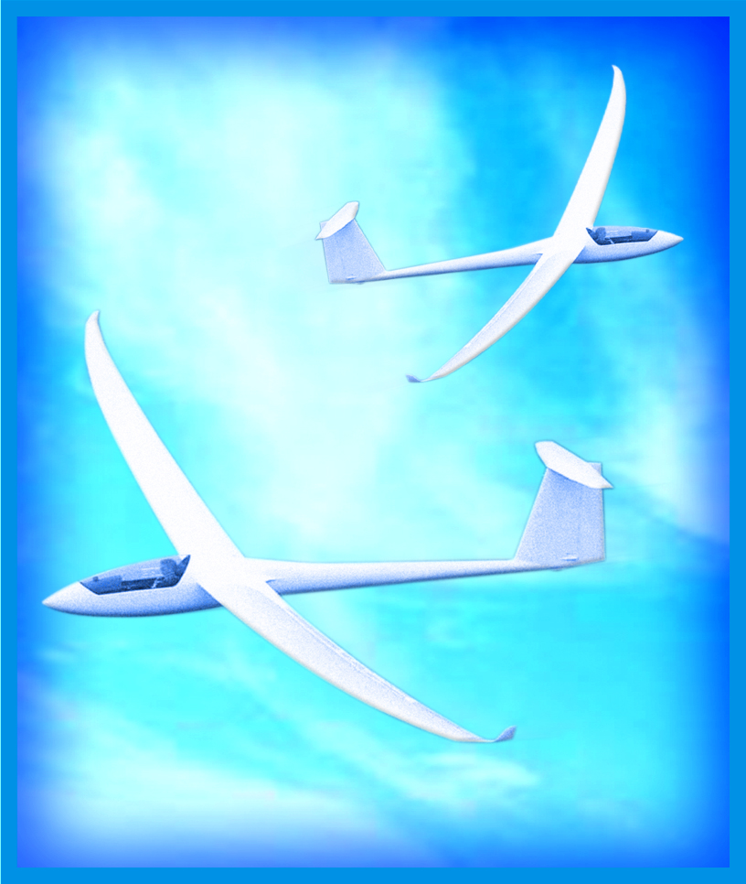
Recommended voluntary practices to advance flight safety, airmanship, and the glider community

Provided to the aviation community by:

[Insert Sponsoring Organization]

©2007 Michael S. Baum. All Rights Reserved.
Introduction
The Glider Aviators’ Model Code of Conduct (Code of Conduct) offers recommendations for all pilots who fly gliders, regardless of their ratings and privileges. It seeks to advance flight safety, airmanship, and the glider community.
The Code of Conduct is not a standard and is not intended to be implemented as one. The Code of Conduct presents a vision of excellence in glider operations. Its principles complement and underscore legal requirements.
Pilots who desire to fly properly equipped gliders under Instrument Flight Rules (IFR) should also refer to the Aviators’ Model Code of Conduct (see Additional Resources, below).
The Principles
The Code of Conduct has seven sections, each containing Principles and Sample Recommended Practices.
- General Responsibilities of Aviators
- Passengers and People on the Surface
- Training and Proficiency
- Security
- Environmental Issues
- Use of Technology
- Advancement and Promotion of GA
The Sample Recommended Practices
Sample Recommended Practices are basic suggestions for using the Code of Conduct principles and tailoring the principles to specific aviation communities and organizations. The Sample Recommended Practices may be modified to satisfy the unique capabilities and requirements of each pilot, mission, aircraft, and GA organization. Some Sample Recommended Practices exceed the provisions of their associated Code of Conduct principles. They are not presented in any particular order.
Benefits of the Code of Conduct
The Code of Conduct benefits pilots and the glider community by:
- highlighting important practices to make pilots better, safer aviators,
- promoting improved pilot training, better airmanship, appropriate pilot conduct, personal responsibility, and pilot contributions to the GA community and society at large,
- encouraging the development and adoption of good judgment and ethical behavior,
- advancing self-regulation through the glider community as an alternative to government regulation, and
- promoting and making flying a more rewarding experience.
Note: Not all flight operations are authorized in all jurisdictions. References to the United States Federal Aviation Administration (FAA) are used as examples. In other jurisdictions, applicable laws and regulations must be followed.
**
Glider Aviators’ Model
Code of Conduct - Principles

I. General Responsibilities of Aviators
Pilots should:
a. make safety the number one priority,
- seek excellence in airmanship,
- develop and exercise good judgment, and apply sound principles of aeronautical decision-making,
- recognize and manage risks effectively,
- maintain situational awareness, and adhere to prudent operating practices and personal operating parameters (e.g., minimums),
- aspire to professionalism,
- act with responsibility and courtesy, and
- adhere to applicable laws and regulations.
Explanation: Code of Conduct Section I serves as a preamble to the Code of Conduct’s other principles. It emphasizes safety, excellence, risk management, and responsibility.
Sample Recommended Practices
- Approach flying with seriousness and diligence, recognizing that your life and the lives of your passengers and others depend on you.
- Recognize, accept, plan for, and do not underestimate the costs of implementing proper safety practices.
- Identify and adapt to changing flight conditions based on sound principles of airmanship and risk management. Be prepared to alter or abort your flight accordingly.
- Recognize the increased risks associated with flying in inclement weather, at night, in congested areas, at high altitude, or over rugged, mountainous, or forested terrain. Plan for and manage such risks prudently.
- Develop, use, periodically review, and refine personal checklists and personal minimums for all phases of flight. Review these materials regularly with a flight instructor or other trusted mentor.
- Make personal wellness and an honest self-evaluation of your fitness a precondition of each flight (for example, by using the I’M SAFE checklist – see, e.g., FAA AC 60-22). Consider undergoing periodic voluntary medical examinations to confirm your fitness.
- Know your personal susceptibility to hypoxia, and establish O₂ personal use parameters—for example, above 8,000 ft. MSL. Use supplemental oxygen on flights where it may be beneficial.
- See and avoid. Practice techniques for seeing and avoiding other aircraft. Scan for traffic continuously. Be particularly vigilant when joining, soaring with, and leaving gaggles, as well as when ridge soaring.
- Listen and be heard. Monitor applicable frequencies to remain aware of the location of other aircraft, and concisely inform other pilots of your position and intentions. Doing so is particularly important in gliders and towplanes that are not transponder-equipped.
- Comply with or exceed the requirements for mandatory inspections, Safety Directives (SDs), Airworthiness Directives (ADs), and Manufacturers Continued Airworthiness Instructions, as appropriate. Adhere to recommended inspections, service bulletins, and checklists.
- Exercise safe ground operations, including: assembly, ground handling, preflight inspection, tiedown, disassembly, and trailering.
- Evaluate the weather before each flight, using all available appropriate aviation resources. Study micrometeorology for your soaring area (including, where applicable, thermal, ridge and/or wave soaring).
- Plan every flight carefully. Calculate weight and balance, and consider the effects of wind on range. Conduct a thorough cross country preflight, including diversion alternatives. Be particularly diligent in planning for the safe premature termination of flight.
- Maintain sufficient altitude to provide suitable landing options in the event of an emergency.
- Adhere to applicable rules and operating practices of your flying club or school, your FBO, flight center, or glider rental provider.
- Seek advice from experienced pilots and flight instructors. Integrate this advice into your flying.
- Adopt a goal-oriented approach to pattern planning and operations:
- Begin pattern planning while approaching the airport/landing area, taking into account all factors that may prevent reaching the intended landing spot.
- Exercise care to maintain an appropriate approach airspeed.
- Be prepared to adapt your pattern in response to changing conditions.
- Use appropriate publications to identify published traffic patterns and relevant aviation activities.
- Work with airport operators and other pilots to harmonize flight operations for both normal and abnormal conditions.
- Exercise extreme caution when flying at unfamiliar airfields.
- Communicate your intended flight itinerary to ground personnel prior to departure, even when flying locally. Update this information in-flight periodically by announcing current status via radio.
- Learn appropriate normal, abnormal, and emergency procedures. Use agreed-upon and consistent visual signals for communication and coordination among the glider pilot, tow pilot/winch operator, and other launch crewmembers. If practicable, use compatible transceivers to enhance such communications.
- Operate rental gliders as if you owned them. Communicate all discrepancies affirmatively and promptly.
- Develop and adhere to conservative operating parameters, such as the following:
- Departures - select a departure alternate landing site for emergency landing just after takeoff in the event of rope break or launch power failure.
- Maneuvering - minimize turns and maneuvers below a predetermined safe altitude except as required for towing, takeoff, landing, or obstacle clearance.
- Landing - be aware of any adverse conditions such as crosswinds, obstacles, and any potentially conflicting ground traffic.
- Emergency landing sites - whenever practicable, fly within range of a suitable emergency landing site. Recognize that the emergency landing site may be private or otherwise restricted property and that the pilot may be on such property without invitation. The pilot should seek to greet, apologize, explain the necessity for the incursion, thank, and promptly take all reasonable measures to remove the glider and remediate any harm caused to the property.
- Night operations - recognize the increased risks associated with night operations.
II. Passengers and People on the Surface
Pilots should:
a. maintain passenger safety first and then reasonable passenger comfort,
b. manage risks and avoid unnecessary risks to passengers and to people and property on the surface and in other aircraft,
c. brief passengers on planned flight procedures and inform them of any significant or unusual risks associated with the flight,
d. seek to prevent unsafe conduct by passengers, and
e. avoid operations that may alarm or disturb passengers or people on the surface.
Explanation: Pilots are responsible for the safety and comfort of their passengers. Passengers place their lives in pilots’ hands, and pilots should exercise sufficient care on their behalf. Such care includes disclosing unusual risks, and exercising prudent risk management. Pilot responsibility also extends to people on the ground and in other aircraft.
Sample Recommended Practices
- Keep your passengers as safe as possible—as though they were your closest loved ones.
- Aspire to treat your passengers with professionalism.
- Plan and fly conservatively to improve safety margins.
- Tactfully disclose risks to each passenger and accept a prospective passenger’s decision to refrain from participating.
- Require that passengers wear seat belts and shoulder harnesses.
- To avoid sun exposure, consider the use of hats, visors, and sun block. In an open cockpit, consider the use of helmet and eye protection.
- Provide a thorough passenger briefing prior to flight (see Additional Resources below).
- Determine the experience, background, and concerns of each passenger. Incorporate them into the preflight briefing and flight activities.
- Refrain from practicing training maneuvers that involve unusual attitudes or slack-line procedures with passengers.
- If available, obtain favorable insurance coverage for passengers, and urge passengers to do so as well. Confirm that there are no misrepresentations on insurance applications, and that you and any other pilot on the policy have complied with all policy provisions.
- Instruct passengers to avoid touching or obstructing critical flight controls, and to keep cameras and the like clear. Brief and maintain a sterile cockpit for takeoffs, landings and other workload-intensive times.
- Encourage passengers to serve as safety resources – for example, by having them identify nearby aircraft, and keep track of landmarks.
- Assess unfamiliar passengers for potential safety and security problems.
- Remember that passenger safety begins on the ramp before ever entering the aircraft. Watch passengers closely and keep them clear of ground-based hazards (e.g., fuel trucks, propellers, slippery surfaces).
III. Training and Proficiency
Pilots should:
- participate in training to maintain and improve proficiency beyond legal requirements,
- participate in flight safety education programs,
- remain vigilant and avoid complacency,
- train to recognize and deal effectively with emergencies, and
- accurately log hours flown and maneuvers practiced to satisfy training and currency requirements.
Explanation: Training and proficiency underlie aviation safety. Recurrent training is a primary component of proficiency and should include both air and ground training. Each contributes significantly to flight safety and neither can substitute for the other. Training sufficient to promote flight safety may well exceed what is required by law.
Sample Recommended Practices
- Pursue a rigorous, life-long course of aviation study.
- Use the manufacturer’s flight manual to determine your glider’s limitations, calculate performance, plan flights, properly secure cargo, (for engine-equipped glider) determine fuel requirements, and calculate weight and balance.
- Follow and periodically review programs of study or series of training exercises to improve proficiency. Consider a training plan that will yield new ratings, certificates, and endorsements.
- Supplement stick-and-rudder training with scenario-based training to build decision-making and risk-management skills.
- Train for flight over challenging environments such as high altitude wave, low altitude ridge, in gaggles with other gliders, or over remote, desert, or mountainous terrain. Train for survival, and carry adequate survival equipment and drinking water.
- Understand and use appropriate procedures in the event of system malfunctions (e.g., lost communications, instrument problems).
- Achieve and maintain proficiency in the operation of avionics.
- Know current aviation regulations and understand their implications and rationale.
- Understand and comply with the privileges and limitations of your pilot certificate.
- Attend aviation training programs offered by industry organizations, the Soaring Safety Foundation, the Soaring Society of America, and the FAA.
- Participate in the FAA Pilot Proficiency Program (“WINGS”).
- Stay updated with diverse and relevant aviation publications.
- Develop a systematic approach to obtaining timely weather briefings and evaluating flight conditions.
- Conduct a periodic review of recent accidents and incidents, focusing on probable causes.
- Periodically demonstrate mastery of applicable practical test standards (PTS), and train to exceed PTS minimums.
- Obtain adequate training before flying an unfamiliar glider, even if you have flown that type in the past.
- Avoid practicing maneuvers in busy airspace or over congested areas.
- Maintain currency that exceeds minimum regulatory requirements.
- Seek to fly at least once monthly during the soaring season. Voluntarily complete a glider proficiency check with a qualified flight instructor at the outset of each soaring season. Emphases should include stall and spin awareness and avoidance.
- Develop a practical understanding of the mechanics and systems of each glider you fly, including assembly/disassembly procedures, and safety checks, including positive control checks.
- Join a type club or support organization for the glider you fly to learn more about its safe operation, including capabilities and limitations.
- Consider maintaining a log to track errors and lessons learned on each flight.
- Register at <http://www.faasafety.gov> to receive announcements of safety meetings and literature, and to review appropriate safety courses online.

IV. Security
Pilots should:
a. seek to maintain the security of all persons and property associated with their aviation activities,
b. remain vigilant and immediately report suspicious, reckless, or illegal activities,
c. secure aircraft to prevent unauthorized use, and
d. avoid special-use airspace except when approved or necessary in an emergency.
Explanation: Enhanced security awareness is essential for the glider community. Threats to security demand responsive action. This Section addresses promoting national security and preventing criminal acts.
Sample Recommended Practices
- Check NOTAMS thoroughly during preflight preparation, and obtain updates during long flights, including NOTAMS for airspace restrictions.
- Always use a transponder with altitude encoding if equipped and operable unless otherwise authorized or directed by ATC.
- Confirm that airport ramp access gates are closed securely behind you to prevent “tailgating” by unauthorized persons.
- Become familiar with Airport Watch (+1-866-GA-SECURE) and other means to report and deter suspicious activities.
- Report security concerns, flight safety hazards or anomalies such as poor radio coverage to the appropriate authorities.
V. Environmental Issues
Pilots should:
a. recognize and seek to mitigate the environmental impact of aircraft operations,
b. for engine-equipped gliders and towplanes, minimize the discharge of fuel, oil, and other chemicals into the environment, during refueling, preflight preparations servicing and flight operations,
c. avoid environmentally sensitive areas,
d. comply with applicable noise-abatement procedures and mitigate aircraft noise in populated or other noise-sensitive areas, and,
e. review and adhere to prudent hazardous materials handling procedures.
Explanation: Reducing pollution caused by aviation will reduce health problems, environmental impact, and unfavorable public perceptions of GA. Environmental issues can also close airports and increase regulatory burdens on GA.
Sample Recommended Practices
- For engine-equipped gliders and towplanes, use a Gasoline Analysis Test Separator (GATS) jar, or other environmentally sound device/procedure for all fuel sampling. Return fuel samples to the fuel tanks or dispose of them properly.
- Learn and adopt environmentally responsible methods for all aspects of glider care, especially degreasing aircraft and handling run-off.
- Adhere to applicable local noise abatement procedures provided safety is maintained. Follow procedures to reduce noise such as reducing engine power as soon as practicable after takeoff (for self-launch gliders and towplanes).
- For engine-equipped gliders and towplanes, if practicable, fly well above noise-sensitive areas, or avoid them altogether.
- Consider the impact of aircraft on wildlife and conform to recommended practices (such as those of the National Park Service minimum altitudes) when flying near wilderness and environmentally sensitive areas.
- Patronize service providers (such as FBOs, repair services, and aircraft cleaners) that adhere to environmentally friendly practices.

VI. Use of Technology
Pilots should:
a. become familiar with and properly use appropriate affordable technologies,
b. monitor applicable airport advisory frequencies and report position concisely when approaching airports without an operating control tower and other higher-risk areas, if radio-equipped,
c. for gliders and towplanes, use transponders or other position-indicating technologies during in-flight operations, if available or otherwise directed by ATC, and
d. if practicable, carry transceivers and navigational equipment and use them in appropriate circumstances.
Explanation: Innovative, compact, and inexpensive technologies have greatly expanded the capabilities and visibility of gliders and towplanes. This section encourages the use of such safety-enhancing technologies.
Sample Recommended Practices
- When practicable, invest in new technologies that advance flight safety. Train to use them properly. Learn and understand the features and limitations of such technologies.
- Inspect and maintain all avionics and flight instruments to keep them operational, current, and approved for the intended flight.
- Recognize that programming avionics may cause distractions, and that distractions may lead to errors.
- Avoid programming navigation systems while under tow.
- Self-announce your position periodically when operating in areas proximate to aviation activities and especially during traffic pattern operations.
- Glider and tow pilots operating in areas that include significant aircraft traffic should consider installing transponders with Mode C capability to enhance their visibility.
- For soaring operations proximate to high-traffic airports, consider discussing operations and technological aids with the appropriate ATC facility.
- Consider purchase, installation, and use of parachutes (personal or ballistic).
- When selecting a glider, consider safety devices such as reinforced cockpit shells, effective canopy ejection devices, automatic control hookups, and cockpit ergonomics.
- Maintain basic flying and navigation skills to enhance safety in the event of the failure or absence of advanced technologies and services.
VII. Advancement and Promotion of General Aviation
Pilots should:
- advance and promote general aviation, safety, and adherence to the Code of Conduct,
- volunteer in and contribute to organizations that promote general aviation, and use their aviation skills to contribute to society at large,
  - demonstrate appreciation for aviation service providers,
  - advance a general aviation culture that values openness, humility, positive attitudes, and the pursuit of personal improvement, and
  - promote ethical behavior within the general aviation community.
Explanation: Glider (and other GA) operations have a well-recognized and worsening public relations problem. Vigilance and responsive action are essential to ensure GA vitality and to enhance the GA experience for pilots and passengers.
Sample Recommended Practices
- Strive to conform fully to the Code of Conduct.
- Serve as a GA ambassador to the public by providing accurate information and refuting misinformation concerning GA activities, and by encouraging potential student pilots.
- Recognize that your actions reflect upon the entire aviation community.
- Volunteer in support of general aviation.
- Join and support the national soaring organization in your country of residence.
- Make charitable use of your aviation resources (for example, by donating flight time to youth).
- Express appreciation to controllers, service personnel, and ground handlers for their assistance and good service.
- Participate in aviation-related fund raising events.
- Invite constructive criticism from your fellow aviators and provide the same when asked.
- Adhere to the highest ethical principles in all aviation dealings, including business practices.
- Seek to resolve disputes informally and congenially.
Additional Resources
- The Glider Aviators’ Model Code of Conduct, the Aviators’ Model Code of Conduct, the Light Sport Aviators’ Model Code of Conduct, the Seaplane Pilots’ Model Code of Conduct, and the Student Pilots’ Model Code of Conduct are available at <http://www.secureav.com>.
- Resources to help [insert your organization here] advance pilot skills and promote flight safety are available at <http://www.[insert sponsor].org/>.
- Further information about gliding is available at:
FAA:
<http://www.faa.gov> (search glider), and
<http://www.faasafety.gov>
EAA:
<http://www.sportpilot.org/>
SSA:
<http://www.ssa.org/>
SSF:
<http://www.soaringsafety.org/>
SecureAv:
<www.secureav.com/Gliders-Listings-Page.html>
- Annotated Commentary helps implementers interpret the Code of Conduct and provides source materials and supplemental aides. Available at <http://www.secureav.com>.
Abbreviations
AD Airworthiness Directive
AGL Above Ground Level
ATC Air Traffic Control
FAA Federal Aviation Administration
FBO Fixed Base Operator
GA General Aviation
IFR Instrument Flight Rules
MSL Mean Sea Level
PTS Practical Test Standards
SD Safety Directive
VFR Visual Flight Rules

Notice
The [insert your organization’s Code of Conduct] is a customized version of the Aviators’ Model Code of Conduct created by Michael S. Baum. ©2007 Michael S. Baum. All Rights Reserved. Terms of Use are available at <http://www.secureav.com>.
Pilots and the aviation community may use the Code of Conduct as a resource for code of conduct development, although it is recommended that this be supported by independent research on the suitability of its principles for specific or local applications and situations. It is not intended to provide legal advice and must not be relied upon as such.
Edits, Errata, Comments
The Code of Conduct is a living document, intended to be updated periodically to reflect changes in aviation practices and the aviation environment. Please send your suggestions, edits, errata, questions and comments to the Permanent Editorial Board at <PEB@secureav.com>.
Acknowledgments
The Glider Aviators’ Model Code of Conduct Drafting Team includes: Michael S. Baum, Richard A. Carlson, Jim Kellett, Martin Weaver, and Dave Wiley. The Code of Conduct has had the benefit of extensive editorial comment and suggestions by a diverse body of the GA community, and beyond. See “Acknowledgments” at <http://www.secureav.com/ack.pdf>. The Permanent Editorial Board of the Code of Conduct is presented at <http://secureav.com/PEB.pdf>.
***
May 24, 2007

